You cannot click on the pen icon because you cannot edit the contribution from th user: yamatoya

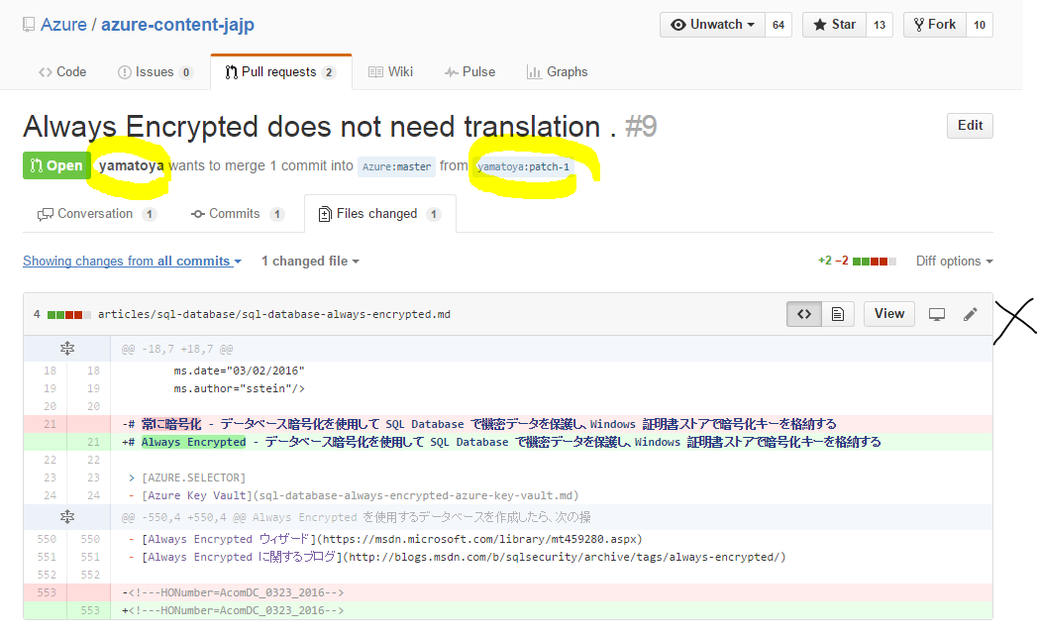

In order to accept the contribution, please, click on “Merge Pull request” at the bottom. This will accept **all** the changes proposed by the contributor.

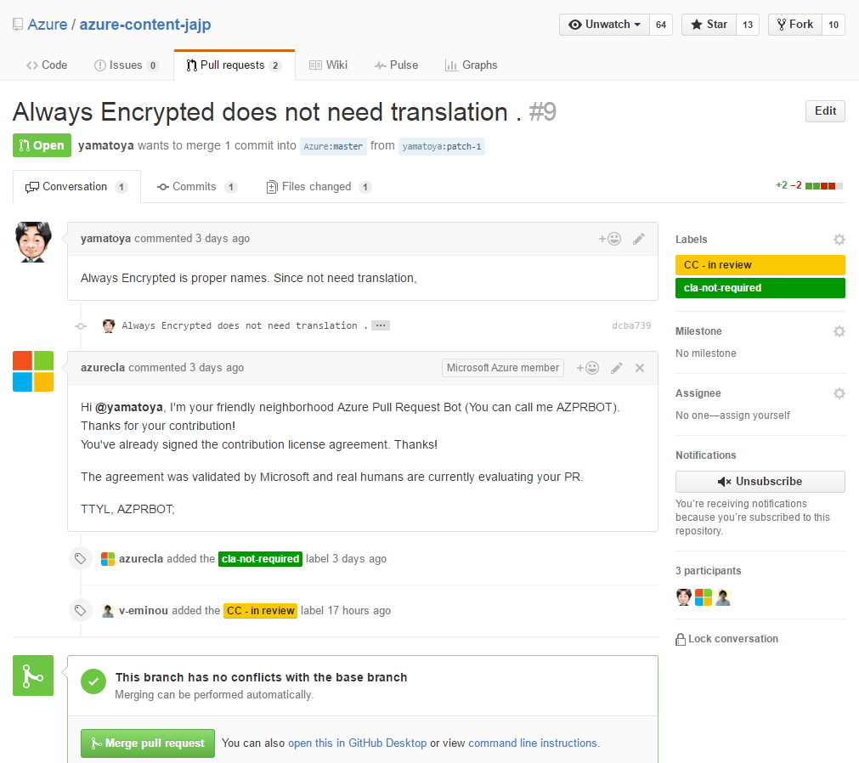

If then you need to reject changes, what you need to do is search for the file in the repo and edit back the changes that you do not agree with. Go to the repo primary page and click on “find file” and then enter the name of the file:

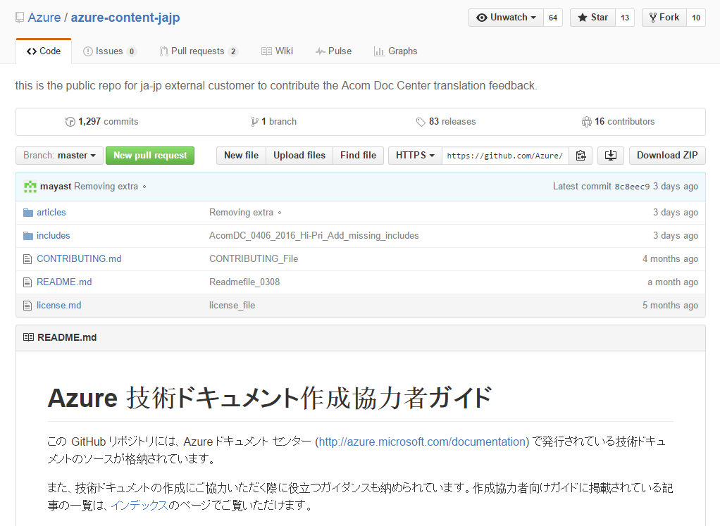

The search results will show below:

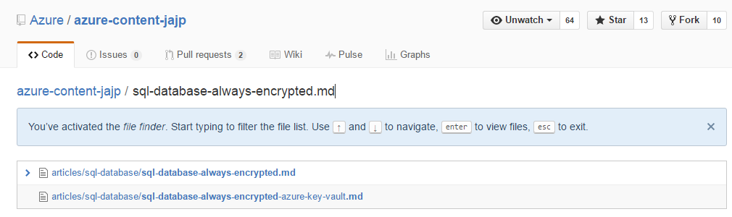

Select your file and now you can edit it without any problems using the pen icon:

